Housing Choice Voucher Program Application
Rental Assistance Bureau – Montana Housing
INSTRUCTIONS:
Applicants will be taken on a first-come, first-served basis by application date. Participation is limited. Complete all questions. All information is required for processing. Incomplete or illegible applications will not be processed.
APPLY ONLINE:
HOUSING.MT.GOV
Check your status & position number online:
WWW.WAITLISTCHECK.COM
MAIL TO:

Montana Department of Commerce
Housing Choice Voucher Program
PO Box 200545
Helena, MT 59620-0545

Family Composition
Family Member | First Name, M.I. of Household Member | Last Name of Household Member | Social Security Number | Relationship to You | Sex | Date of Birth (Month/Date/Year)
Head of Household |  |  |  | Self
Spouse or Co-Head |  |  |  | Spouse or Co-Head
Are you interested in Moderate Rehabilitation (MOD REHAB)?
There may be MOD REHAB unit available in your area during your waiting period?
Contact your local regional office below for more information
Yes No
Contact Information
Mailing Address (Required) ______________________________________________
City __________________________ County __________________________
State _________ Zip __________ Home # _________________________
Cell # _________________________ Work # __________________________
Email ________________________________________________________________
Alternate Contact Person ________________________________________________
Alternate Contact # ____________________________________________________
Alternate Contact Email _________________________________________________
Gender Identification
Please respond for Head of Household only
- Female
- Male
- Trans Female
- Trans Male
- Gender Non-Conforming
- Decline to Answer
Household Demographic Information
Please select all that apply.
- Age 62 or over
- Disabled
- Single Parent
- Full-time student
- Veteran
Race, Ethnicity, Citizenship
Race |  |  |  |  | Ethnicity |  | Citizenship
 | American Indian or Alaska Native |  | Native Hawaiian / Other Pacific Islander |  | Hispanic/Latino |  | Citizen
 | Asian |  | White |  | Non-Hispanic/Non-Latino |  | Legal Resident
 | Black or African American |  | Decline to Answer |  | Decline to Answer |  | Migrant
Racial and ethnic data is collected for statistical purposes.

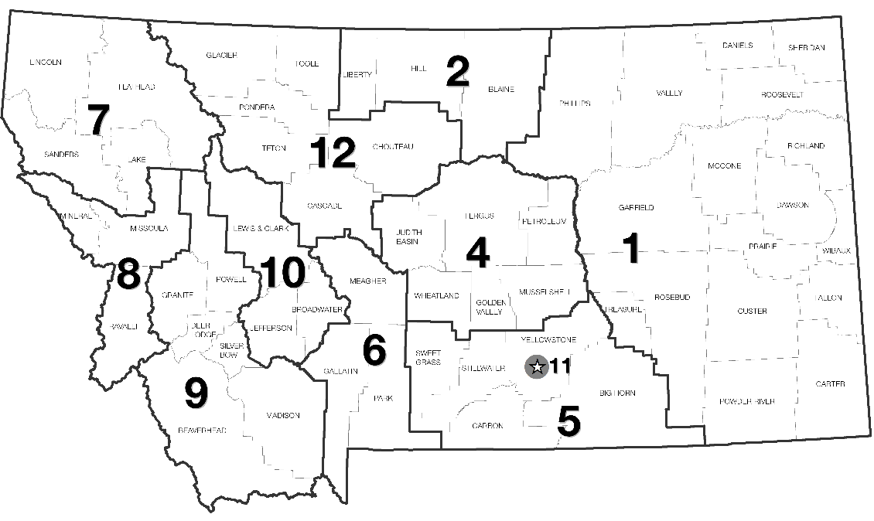
Regional Offices – Choose only one
- Region 1 – Action for Eastern Montana
- Region 2 – HRDC 4, Havre
- Region 4 – HRDC 6, Lewistown
- Region 5 – HRDC 7, Billings
- Region 6 – HRDC 9, Bozeman
- Region 7 – Community Action Partnership, Kalispell
- Region 8 – HRC XI, Missoula
- Region 9 – Action, Inc., Butte
- Region 10 – Helena Housing Authority
- Region 11 – Housing Authority of Billings
- Region 12 – Opportunities, Inc., Great Falls
Limited Preference
IF your household contains a disabled member under the age of 62, check any of the following that applies
I am transitioning out of institutional and other segregated settings.
I am at serious risk of institutionalization.
I am currently experiencing homelessness and/or am an eligible person(s) that are referred by the state of Montana’s Coordinated Entry System (CES).
I have previously experienced homelessness and am currently a client in a Permanent Supportive Housing or Rapid Rehousing project.
Privacy Act Statement – The Department of Housing and Urban Development (HUD) is authorized to collect this information by the U.S. Housing Act of 1937, as amended (42 U.S.C. 1437 et. seq); the Housing and Urban-Rural Recovery Act of 1983 (P.L. 98-181); the Housing and Community Development Technical Amendments of 1984 (P.L. 98-479); and by the Housing and Community Development Act of 1987 (42 U.S.C. 3543). The information is being collected by HUD to determine an applicant’s eligibility, the recommended unit size, and the amount the tenant(s) must pay toward rent and utilities. HUD uses this information to assist in managing certain HUD properties, to protect the Government’s financial interest, and to verify the accuracy of the information furnished. HUD, the owner or management agent (O/A), or a public housing agency (PHA) may conduct a computer match to verify the information you provide. This information may be released to appropriate Federal, State, and local agencies, when relevant, and to civil, criminal, or regulatory investigators and prosecutors. However, the information will not be otherwise disclosed or released outside of HUD, except as permitted or required by law. You must provide all the information requested. Failure to provide any information may result in a delay or rejection of your eligibility approval.
Income
Family Member | Wages / Salaries | SS or Pensions | Public Assistance (incl. 551) | Income from Assets | Other | Family Assets (Net or Market Value of Real Property & Liquid Assets)
Tenant(s) Statement – I/We certify that the statements above are true and complete to the best of my/our knowledge and belief. I/We understand that false statements or information are punishable under Federal Law.
By signing this form, you are indicating that you have read the above Privacy Act Statement and are agreeing with applicable certification.
NOTE: You are responsible for keeping your mailing address and phone number current with MDOC for the entire time you are on the Waiting List (approximately 1-3 years). You will be removed from the Waiting List if you fail to respond to Housing Choice Voucher mailings and you will be required to reapply and begin the Waiting List process.

SIGNATURE DATE

